Assuming that we were able to list and rank fitting candidates, we then employ a review procedure, as each candidate needs to be reviewed and then determined how good a fit they are through manual inspection. This procedure is done manually and at the end of this manual review, we might choose not the first fitting candidate in the list but maybe the 7th candidate in the list. If that happens, we are interested in being able to re-rank the previous list based on this information. This supervisory signal is going to be supplied by starring the 7th candidate in the list. Starring one candidate actually sets this candidate as an ideal candidate for the given role. Then, we expect the list to be re-ranked each time a candidate is starred.

The data comes from our sourcing efforts. We removed any field that could directly reveal personal details and gave a unique identifier for each candidate.  
  
Attributes:  
id : unique identifier for candidate (numeric)  
job_title : job title for candidate (text)  
location : geographical location for candidate (text)  
connections: number of connections candidate has, 500+ means over 500 (text)  
Output (desired target):  
fit - how fit the candidate is for the role? (numeric, probability between 0-1)  
Keywords: “Aspiring human resources” or “seeking human resources”

**1. Data + features**

From the sheet we have:

* id – numeric
* job_title – free text
* location – free text
* connections – text: “44”, “500+”, etc.
* fit – numeric label (can rescale to 0–1 by dividing by 100)

For each candidate create features:

**1.1 Text features**

Use a sentence embedding model (e.g. any BERT/SBERT-style model) to convert text to vectors:

* e_title = embed(job_title)
* e_loc = embed(location) (lower weight)
* e_query = embed(keywords) – e.g. “aspiring human resources”

Then compute similarities:

* sim_title_query = cosine(e_title, e_query)
* optionally sim_loc_query if location matters

This already captures “aspiring HR”, “seeking HR”, “HR Generalist”, “People Development” etc. even when not exact matches.

**1.2 Numeric features**

* connections_num:
  + if value = “500+” → 500 (or 600); else int(value)
  + normalize: conn_norm = (connections_num – mean)/std
* Simple binary flags from job title using regex:
  + has_hr = 1 if "human resources" or "HR" in lower(job_title) else 0
  + has_seeking_or_aspiring = 1 if "aspiring" or "seeking" in title
  + seniority flags: is_manager, is_intern, etc.

So the feature vector for candidate *i* is something like:

x_i = [sim_title_query, conn_norm, has_hr, has_seeking_or_aspiring, is_manager, …]

**2. Base model: predict fit ∈ [0,1]**

Train a regression / ranking model using historical fit:

* **Simplest**: logistic regression or gradient-boosted trees on x_i
* **Better for ranking**: a learning-to-rank model like LambdaMART / XGBoost rank

Pointwise version:

* Input: x_i
* Target: fit_i / 100
* Loss: MSE or logistic

The model outputs a base score:

base_fit_i ∈ [0,1]

You can already use this to sort candidates for a new role:  
*Compute features vs the current role keywords, run through the model, sort by base_fit.*

**3. Online re-ranking with stars**

When you star candidate *j*, you’re saying:

“For this role, candidates similar to *j* are particularly good.”

We can encode that as an **online prototype** in embedding space.

**3.1 Maintain a “role prototype” vector**

For the current role, keep:

* The query embedding e_query
* A running prototype of starred candidates:

p_t = mean( e_title(j) for all starred j so far )

At time *t* (after some stars) define a **similarity-to-prototype**:

sim_proto_i^t = cosine( e_title(i), p_t )

**3.2 New ranking score after each star**

Combine base model prediction and prototype similarity:

score_i^t = w1 * base_fit_i + w2 * sim_title_query(i) + w3 * sim_proto_i^t

with e.g. w1 = 0.5, w2 = 0.2, w3 = 0.3 as a starting point, and later learn these from data across roles.

Algorithm:

1. Initially (t=0):
   * score_i^0 = w1 * base_fit_i + w2 * sim_title_query(i)
   * Rank candidates by score_i^0.
2. User reviews candidates; stars candidate k (maybe the 7th).
3. Update prototype p_1 = e_title(k).
4. Recompute sim_proto_i^1 for all i.  
   New score: score_i^1 = w1*base_fit_i + w2*sim_title_query(i) + w3*sim_proto_i^1.
5. Rank again → similar candidates to the star move up.
6. If user stars another candidate m, update p_2 = mean(e_title(k), e_title(m)) and repeat.

This gives you **continuous re-ranking** that reflects the reviewer’s preferences while still anchored by the base model.

**3.3 “Getting better with each star”**

You can show this quantitatively:

* Offline: treat “true best fits” as those with high fit in the sheet.
* Simulate:
  + Start with base ranking.
  + Assume the user eventually stars one of the top-N true fits.
  + After each simulated star, recompute scores and measure **NDCG@K / Precision@K**.
  + Those metrics should rise as more stars are used.

In production you can show:

* “After your last star, X of the top 10 are similar to your starred candidates (previously Y of 10).”

**4. Filtering out clearly bad candidates**

You can layer **hard filters** above the ranking:

1. **Semantic relevance filter**

Require minimum similarity:

* sim_title_query >= τ (e.g. 0.4–0.5 from training)
* Optionally has_hr = 1

Anyone whose job title embedding is far from the HR keywords is dropped.

1. **Rule-based patterns**

If the title contains words indicating a totally different function (“Software Engineer”, “Data Scientist”, “Nurse”), discard unless they also contain HR strings.

1. **Binary classifier**

Train a simple classifier “Relevant-HR vs Not-HR” using your labelled data.

* First stage: classifier filters out obviously irrelevant ones.
* Second stage: ranking model scores only the relevant set.

This reduces noise and the amount of manual review.

**5. Choosing a cut-off that generalises**

Because your model outputs (roughly) calibrated probabilities, you can:

1. On historical data, pick a threshold θ on predicted fit such that:
   * Precision among candidates with fit_pred ≥ θ is, say, 80%.
2. Use that same θ for **other roles**, since the score is query-conditioned (it already takes the role keywords into account).

Alternative / simpler:

* Always keep **top-K** or top **α%** of the ranked list (e.g. top 30 or top 20%) and drop the rest.
* Or use a dynamic cut-off: keep all candidates whose score is within, say, 80% of the best candidate’s score:  
  score_i ≥ 0.8 * max_j(score_j).

This avoids losing “high potential” outliers while still trimming the tail.

**6. Ideas to reduce human bias & automate more**

A few concrete things you can do:

**6.1 Blind(er) review UI**

Even though you’ve removed direct PII, some fields still act as proxies:

* Location (geo, language, socio-economic info)
* Connections (network size)

You can:

* Hide location & connections in the **first pass**; show only after a candidate is shortlisted.
* Randomise the order of candidates within narrow score bands to avoid positional bias.

**6.2 Consistent, model-assisted decisions**

* Always start from the **model’s ranking**, not gut feeling or alphabetical order.
* Provide explanations: show why a candidate is ranked high (e.g. “Title similar to: aspiring human resources; high prior ‘fit’ scores for similar profiles”).

**6.3 Active learning instead of manual trawling**

Use the starring as **active learning**:

* Instead of asking the reviewer to go down the list, occasionally surface **diverse candidates** that the model is uncertain about (scores near 0.5).
* Their stars (or explicit “not relevant”) give the model information where it’s least sure, improving it faster and reducing bias towards “typical” profiles.

**6.4 Fairness monitoring**

If later you add back any demographic or proxy variables (even just for monitoring, not for training):

* Measure whether certain groups consistently receive lower scores.
* Use post-processing constraints (e.g. ensure proportion of shortlisted candidates from different regions is not worse than historical baselines unless justified).

**7. Putting it all together (pipeline)**

For a new role with keywords K:

1. **Retrieve** candidates using a basic keyword / semantic search (your current semi-automatic sourcing).
2. **Pre-filter** with relevance classifier + similarity threshold.
3. **Compute features** and **predict base_fit** for each candidate.
4. **Initial ranking** by score_i^0 = w1 * base_fit_i + w2 * sim_title_query(i).
5. **Reviewer stars** a candidate → update prototype p_t, recompute sim_proto_i^t, re-rank by score_i^t.
6. Repeat step 5 as more stars come in.
7. Apply a **cut-off** (probability threshold or top-K) for final shortlist.

This gives you:

* A numeric **fit score** for every candidate (0–1)
* Automatic **re-ranking** after each star
* A principled way to **filter and cut** while still letting humans override when needed
* A path to **learning from feedback** and gradually reducing manual work and bias.

If you want, next step I can sketch concrete pseudo-code / Python for the scoring and re-ranking logic, or show a toy example with a few rows from your sheet and how the ranking changes after starring one candidate.

### What is BERT?

* How BERT is used in NLP task
* How BERT works?
* 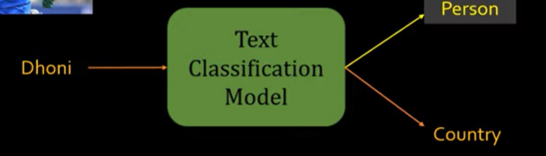
* 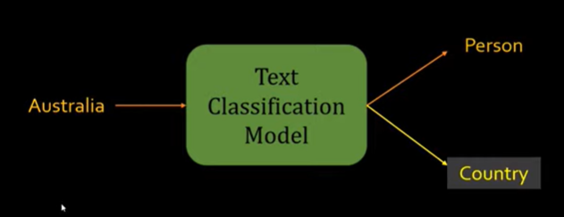
* 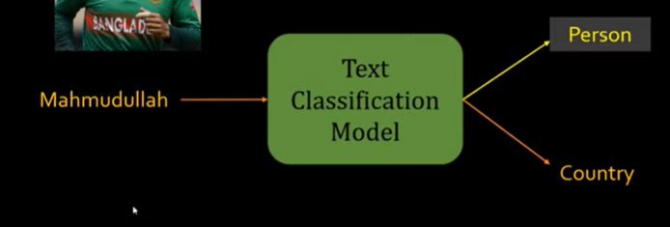
* The point here is to understand how we capture similarities between two words?
* Thing about two homes, how they are similar?

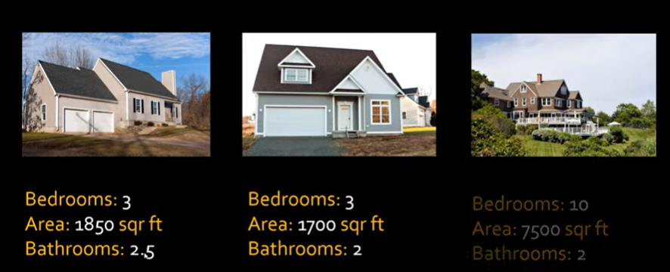

* Here first two homes are similar while third one is not as it is far bigger in terms of its area!
* If we derive the features then we can say if those two objects are similar or not!
* Similarly, think about how we can translate the words in the following figure



Here are their respective features:

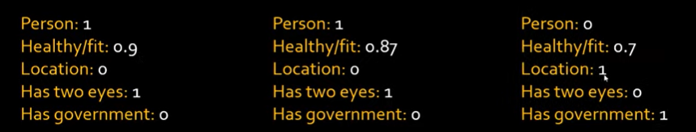

We can see here that Dhoni & cummins are kind of similar e.g. both person, fit/healthy, eyes etc but Australia is different as it is not person and also different features!

* Now take these features into vectors and compare the vectors

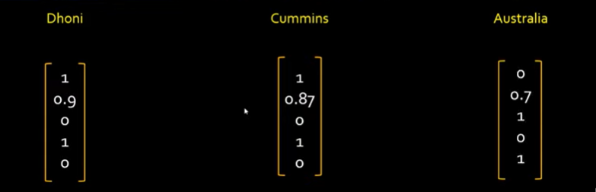

Seeing the values in vectors , we can see Dhoni is more similar to Cummins while cummins and Australia are not similar.

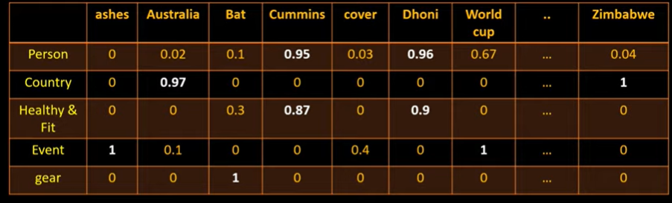

We can generate feature vectors and these feature vectors are called word embeddings.

e.g. these two are similar

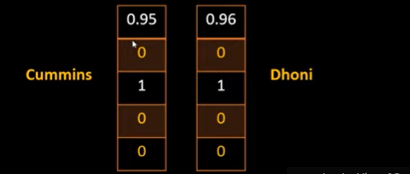

Also, these two are similar:

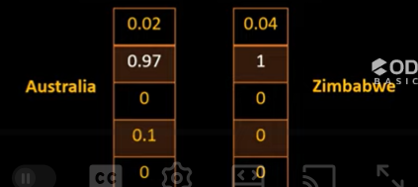

We can generate words embedding from vectors is using Word2Vec.

* See video related to word2vec for further details for this author to have a good understanding.
* Models can figure out features automatically.

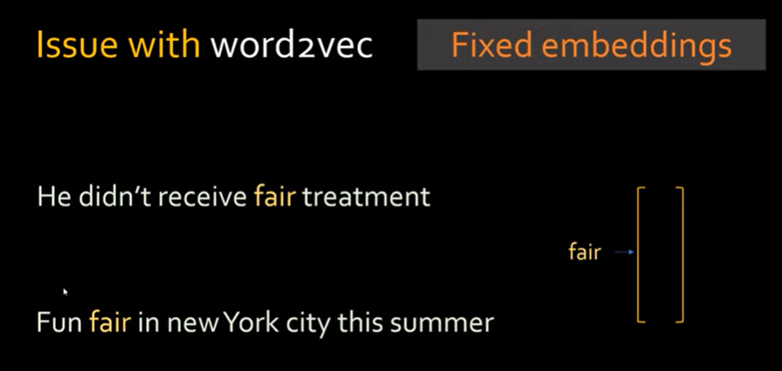

* Word2vec generates fixed embedding vector which is not right as meaning here for fair is different. ..
* Need to see whole sentence and then generate correct representation or contextualize meaning of word. … this is what BERT can allow you to do i.e. can generate contextualized embeddings. So need to see whole sentence to generate the number representation of word.

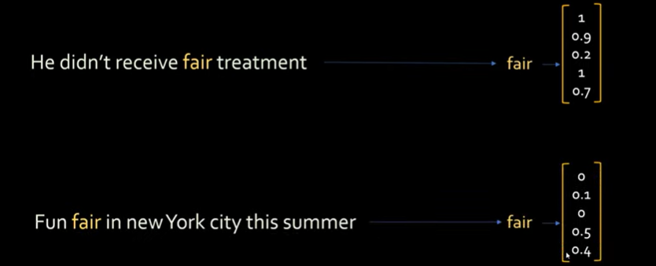

Here we can see vector of “fair” is quite different

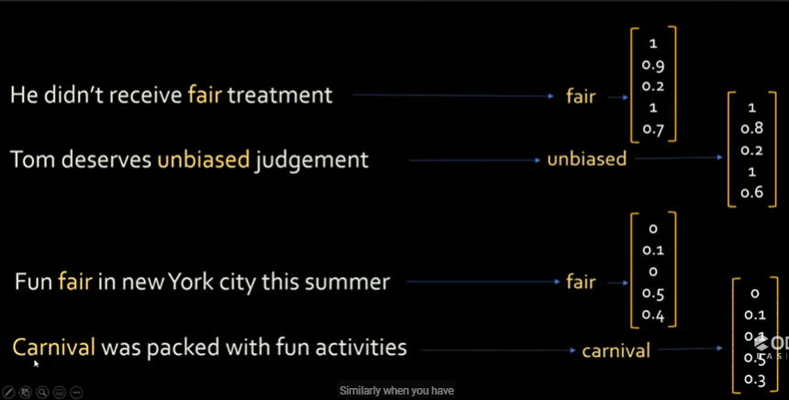

BERT is very powerful… generate meaningful number representation of a given word.

BERT can also generate meaningful number representation of a whole sentence.

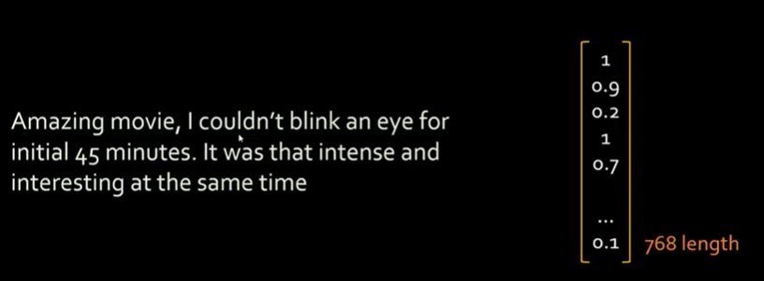

See the blog by Jay Alammar which is a very good explanation



Two versions of BERT… i.e. BERT base and BERT large.

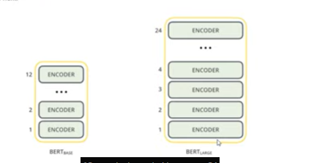

BERT is trained on 2500M words in Wikipedia. 800M words from different books.



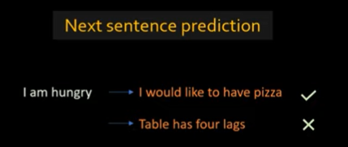

See above example of next sentence prediction … where I would like to have pizza seems more appropriate and related to “I am hungry” instead of “Table has four legs”

Search in google got better with BERT model.

BERT – **Bi**directional **E**ncoder **R**epresentation from **T**ransformers

Go to tensorflow hub and you can go to models and see BERT models.

<https://www.tensorflow.org/hub>

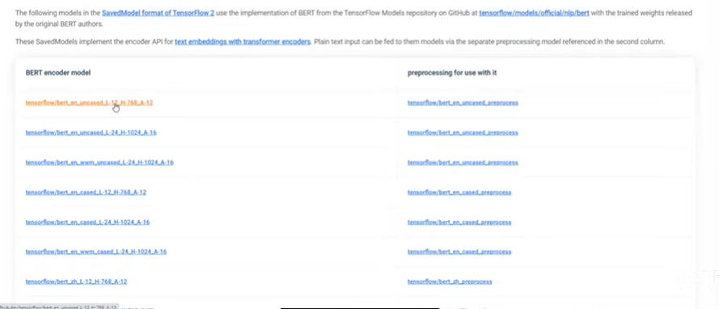

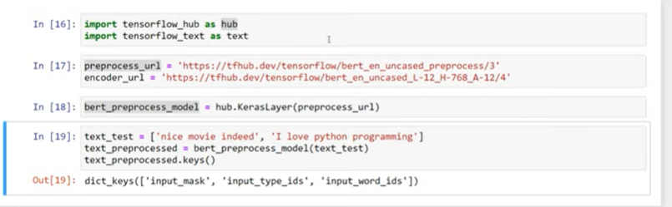

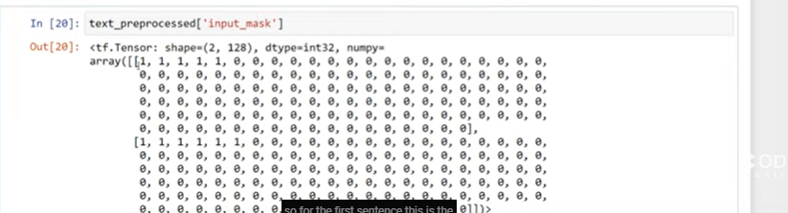

Here shape is 2, 128 as we have got two sentences.

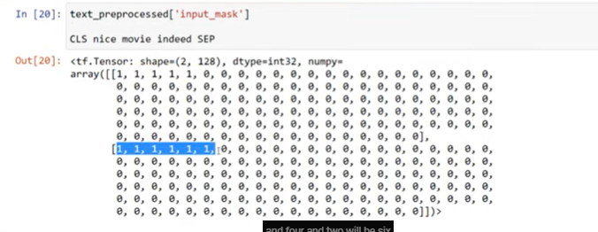

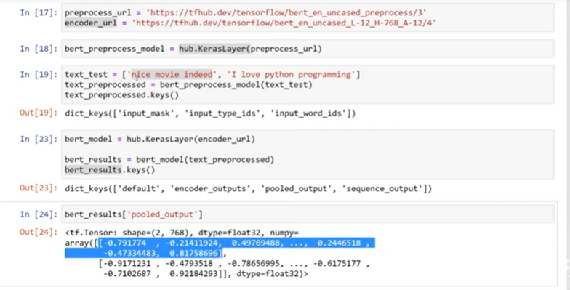

The 768 vector here accurately represents the statement “nice movie indeed” in form of numbers.

Similarly for the second statement the above is an embedding vector (last statement result).

We can use these vectors in our natural language processing tasks.

BERT help you generate a helpful vector out of your statement.

“sequence_output” is individual word embedding vector.

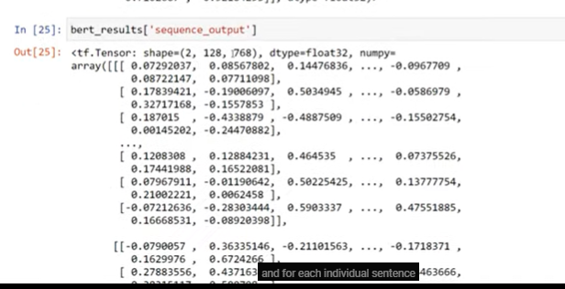

For each word, there is a 768 sized vector.

If we see length of encoder output, it would be 12

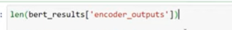

The reason length is 12 as we are using base BERT model as it is of 12 layer and each layer has 768 size embedding vector.

Now see the first one (or first layer)

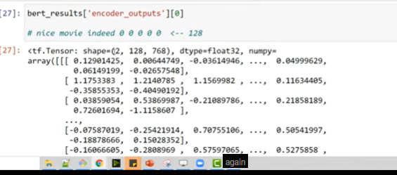

It is still 2, 128, 768

Here 2 – because we have got 2 sentences

128 – statement has got 128 words including the padding

For each word, there is 768 size embedding vector.

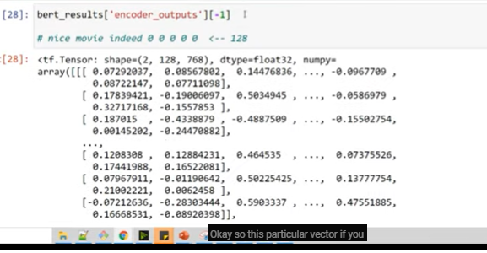

### Word2Vec

* Way to represent words in form of numbers / vectors
* Every word has some sort of features
* E.g. for King, we have the following features:

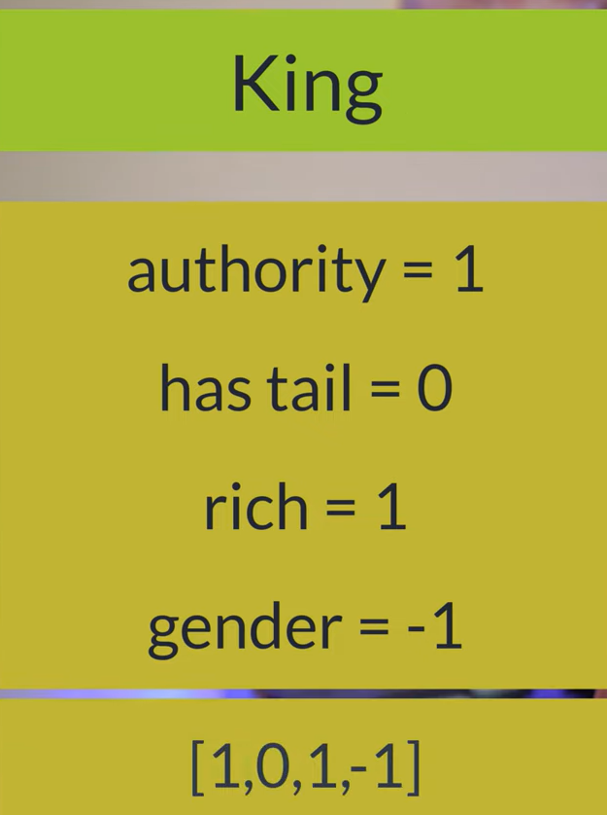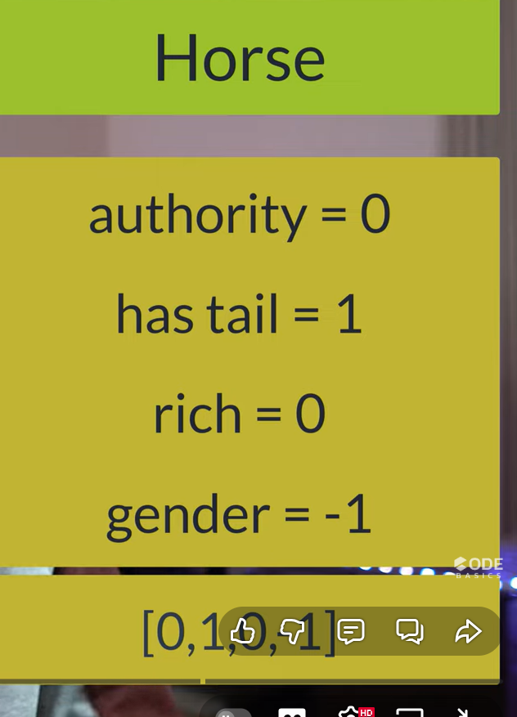

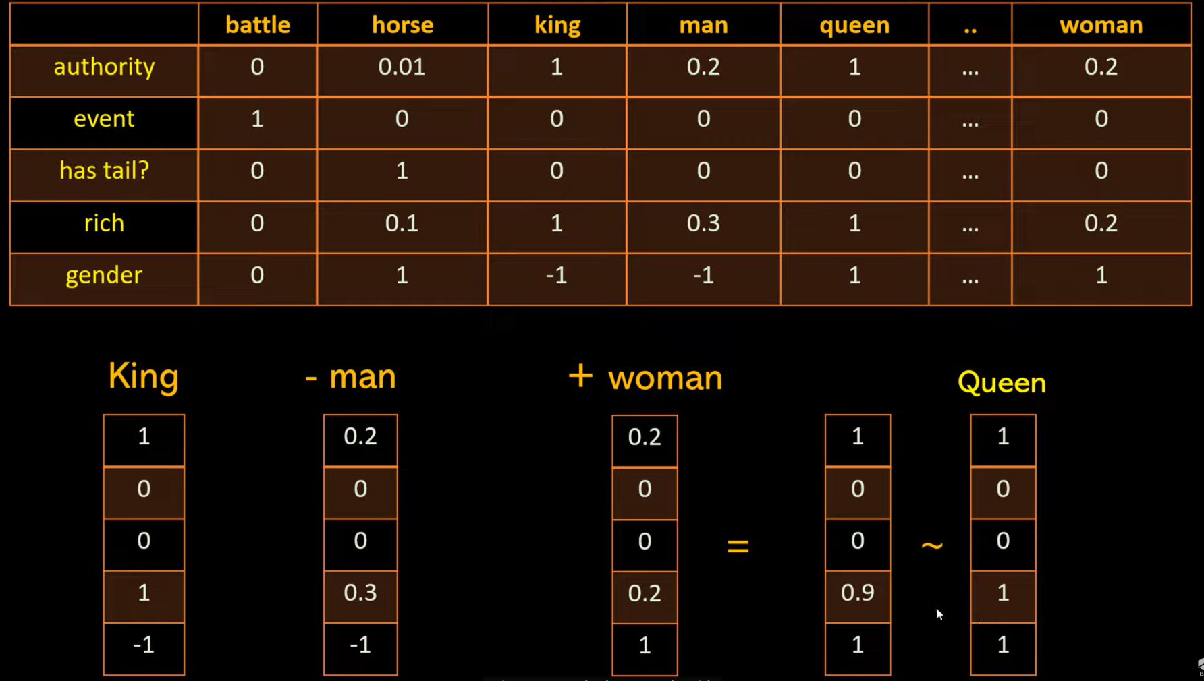

* See this example , where king – man + woman => it results into a vector which is almost or very close to the one for Queen!!
* Embeddings are not hand carfted. Instead they are learnt during neural network training.

1. Take a fake problem
2. Solve it using neural network
3. You get work embeddings as a side effect.

Fake problem: fill in a missing word in a sentence

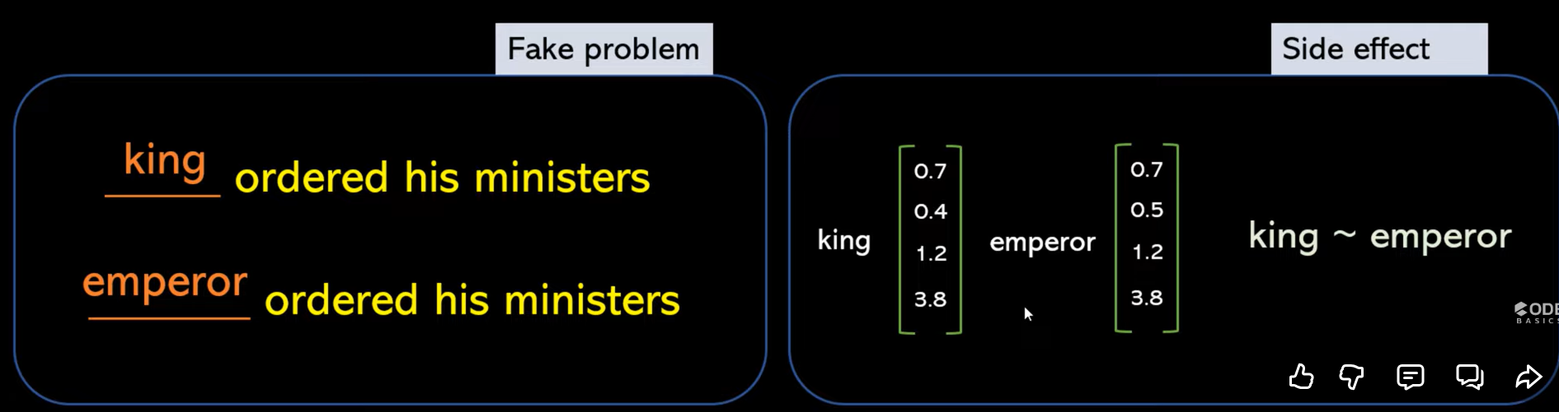





Meaning of word can be inferred by surrounding words. Surrounding words are called context.

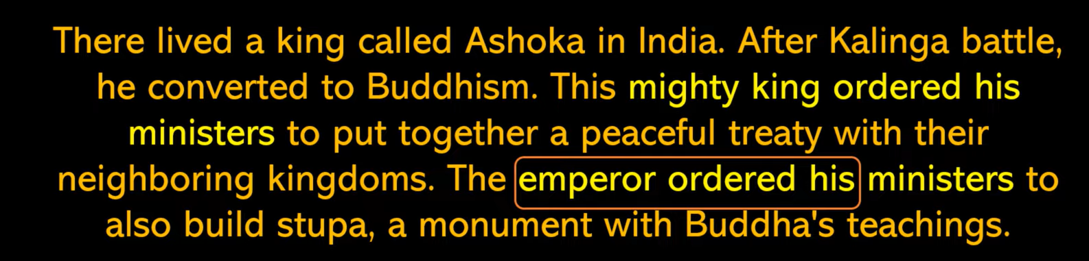

**Training samples**

Lived, a -> There

A, king -> lived

Ordered, his -> king

Ordered, his -> emperor

* Generated this matrix using one hot encoder.. you can see it is 1 only when we match the word e.g. ordered or his!

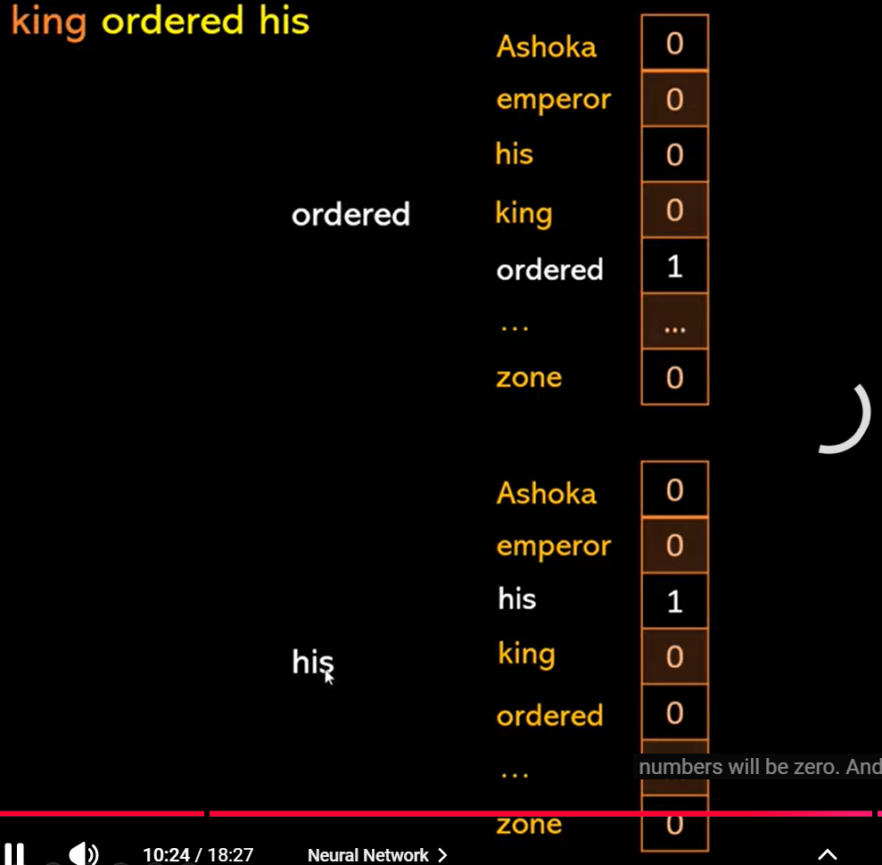

* Size of embedding vector is chosen as per experience or by hit n tria.

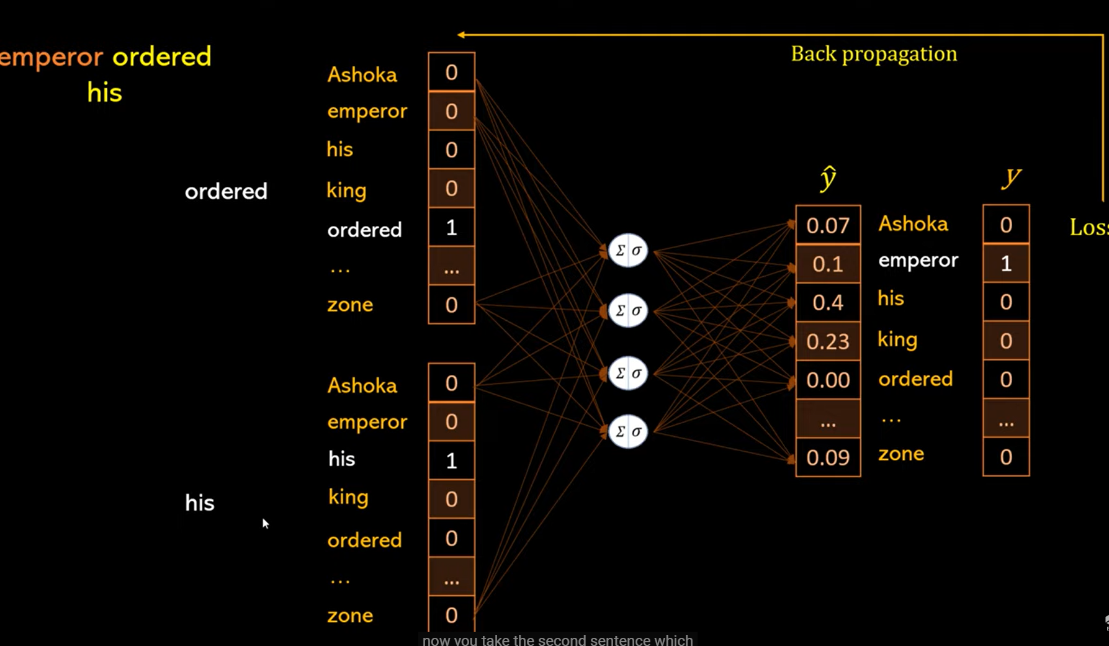

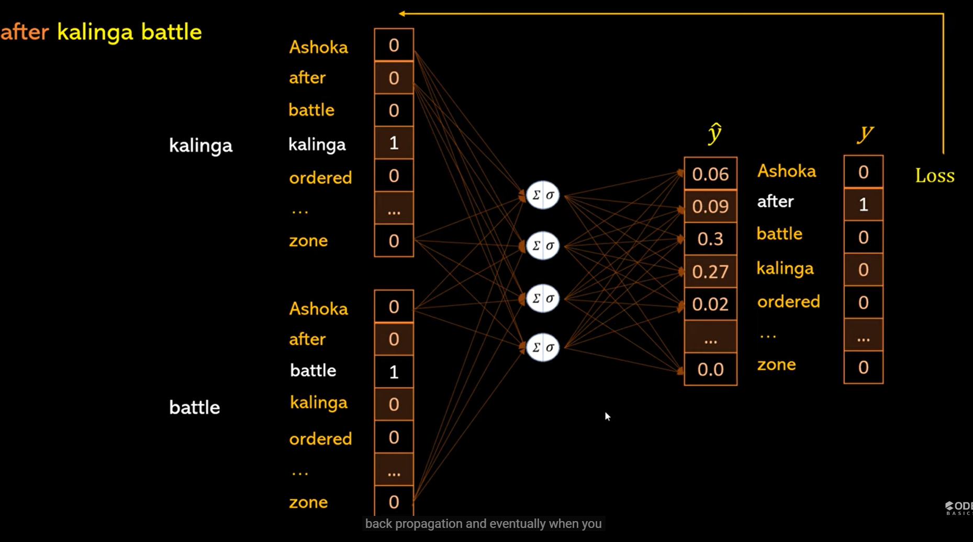

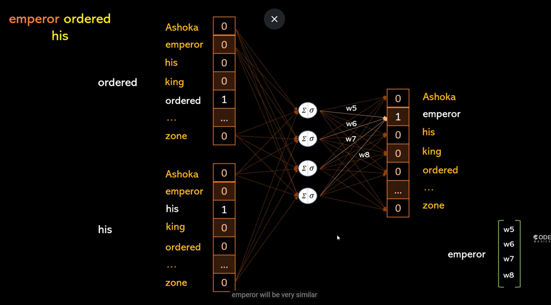

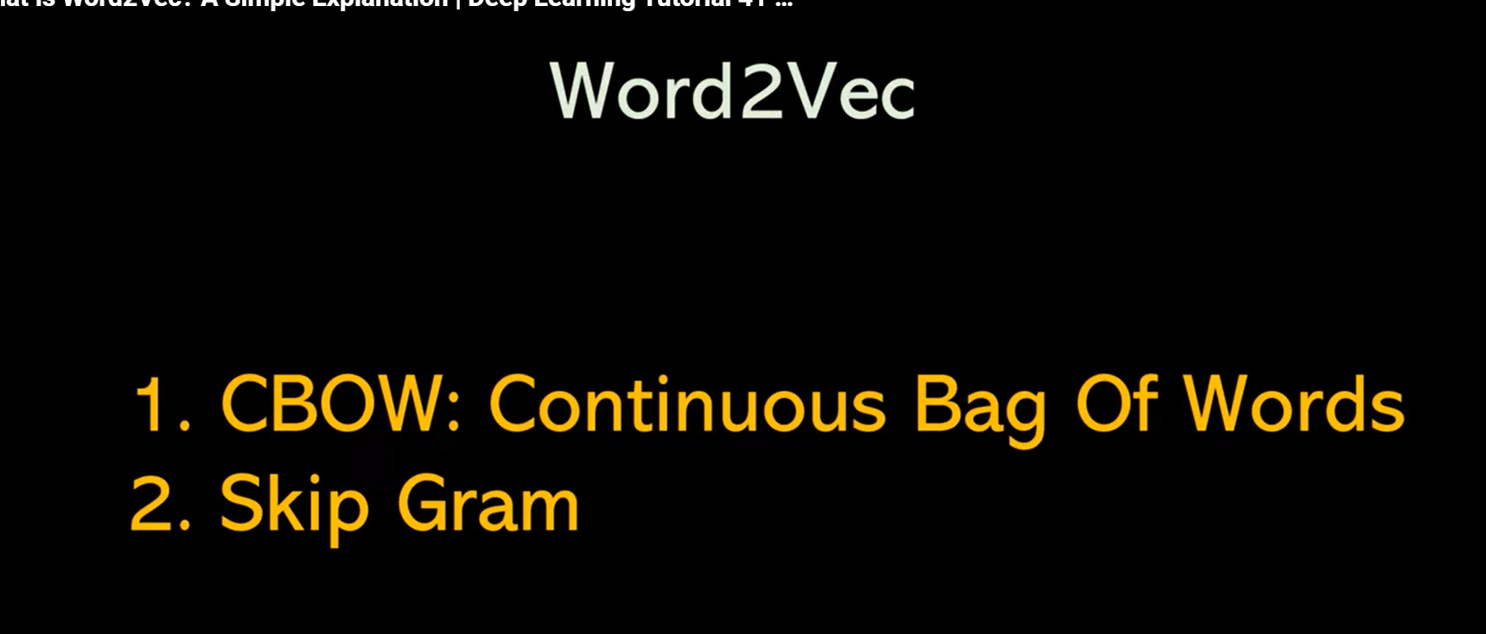

Wonderful things can be done with word2vec… !

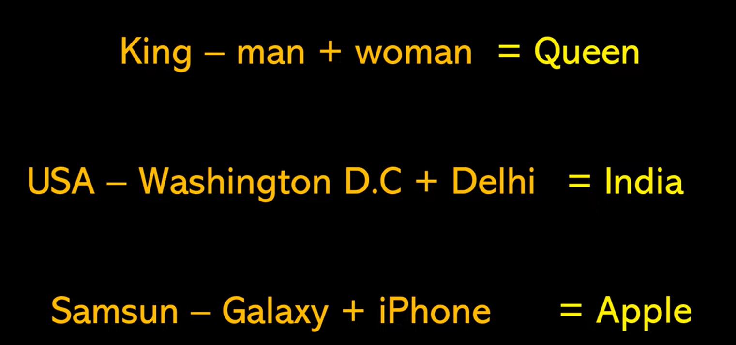

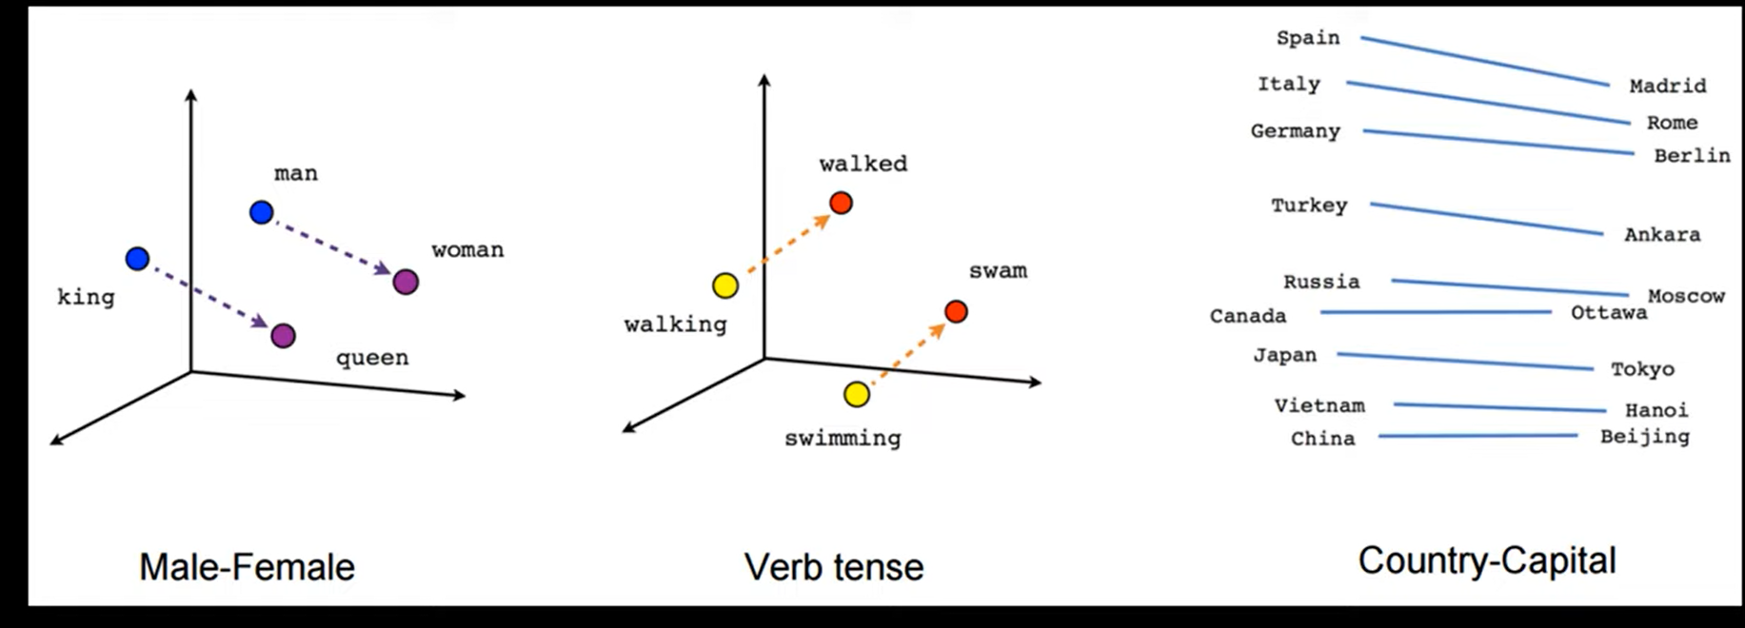



### Word2vec – coding part